Hindeline töö

CREATE PROCEDURE GetDoctorPatients1

@DoctorID INT

AS

BEGIN

SELECT

p.Name AS PatientsName,

d.Name AS DoctorName

FROM Patients p

JOIN Doctor d ON p.DoctorID = d.DoctorID

WHERE d.DoctorID = @DoctorID;

END;

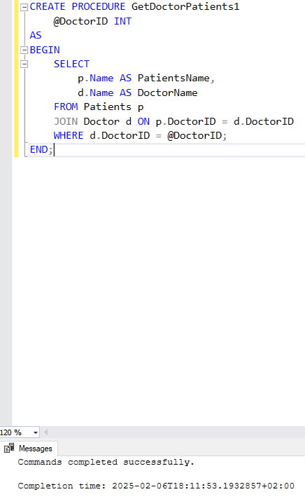

Select Name, Gender, CheckInDate, WardNr, WardType

from Patients

Full join Ward

on Patients.PatientID = Ward.WardID

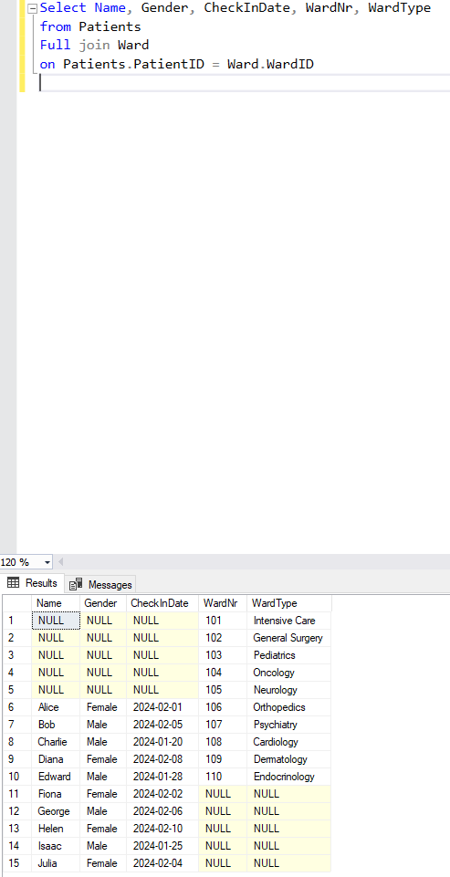

Select Name, Gender, PhoneNr, CheckInDate

from Patients

right join Ward

on Patients.PatientID = Ward.WardID

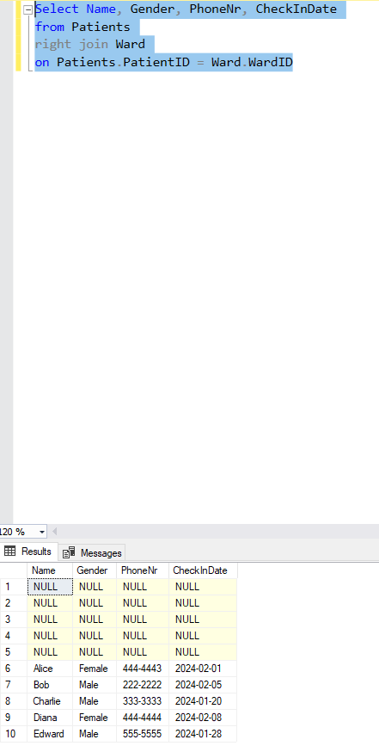

Select Name, Gender, DepartmentName

from Doctor

left join Department

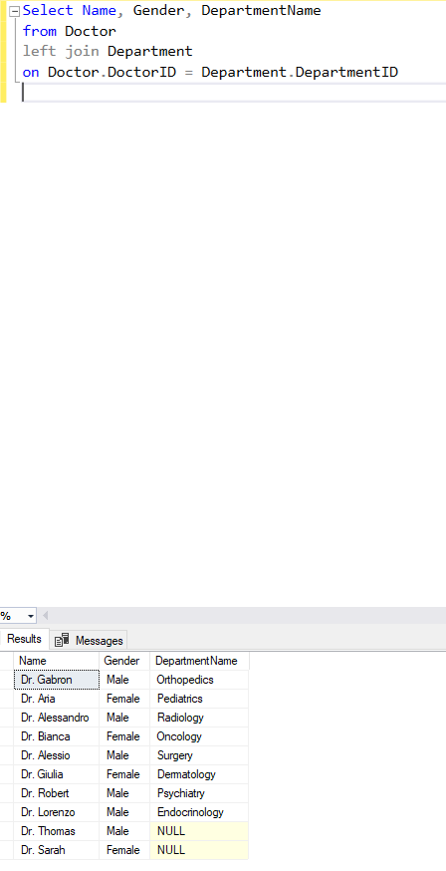on Doctor.DoctorID = Department.DepartmentID

INSERT INTO Ward (WardNr, WardType, DoctorID, PatientID) VALUES

(101, 'Intensive Care', 1, 3),

(102, 'General Surgery', 2, 1),

(103, 'Pediatrics', 3, 2),

(104, 'Oncology', 4, 4),

(105, 'Neurology', 5, 5),

(106, 'Orthopedics', 6, 6),

(107, 'Psychiatry', 7, 7),

(108, 'Cardiology', 8, 8),

(109, 'Dermatology', 9, 9),

(110, 'Endocrinology', 10, 10);

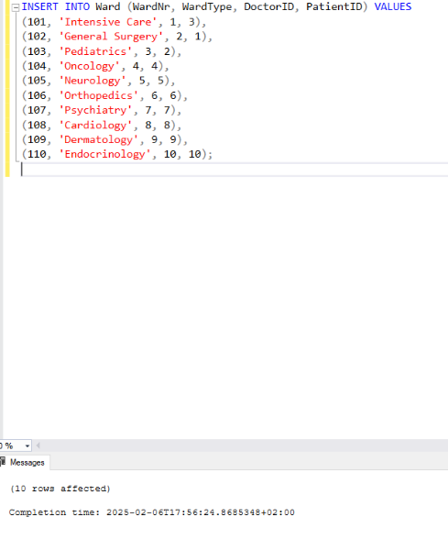

INSERT INTO Hospital (Name, Adress, Departments, Wards) VALUES

('Tallinn Central Hospital', 'Tallinn, Estonia', 5, 20),

('Tartu University Hospital', 'Tartu, Estonia', 7, 25),

('Narva General Hospital', 'Narva, Estonia', 4, 15),

('Parnu Hospital', 'Parnu, Estonia', 6, 18),

('Kohtla-Järve Hospital', 'Kohtla-Järve, Estonia', 3, 12),

('Viljandi Hospital', 'Viljandi, Estonia', 4, 14),

('Rakvere Hospital', 'Rakvere, Estonia', 3, 10),

('Haapsalu Hospital', 'Haapsalu, Estonia', 2, 8),

('Kuressaare Hospital', 'Kuressaare, Estonia', 1, 5),

('Valga Hospital', 'Valga, Estonia', 2, 7);

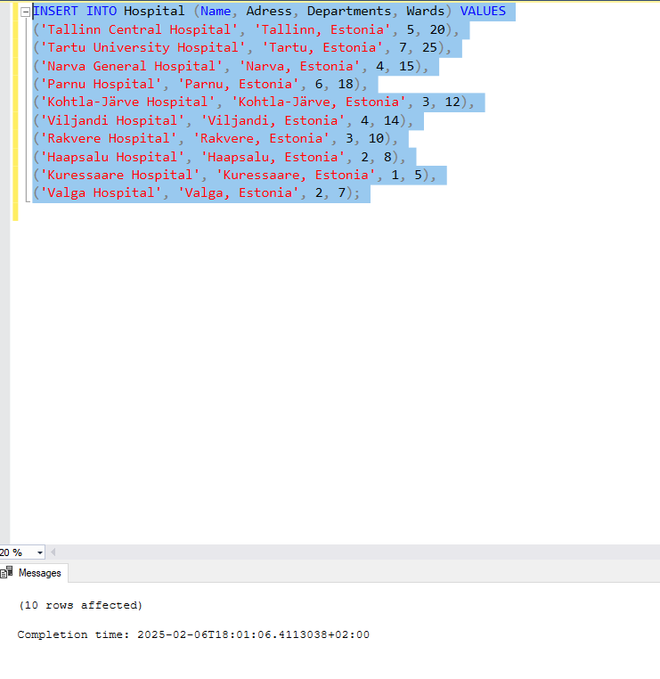

INSERT INTO Department ( DepartmentName, DepartmentSpecalty, DoctorID) VALUES

('Cardiology', 'Heart Diseases', 1),

('Neurology', 'Brain & Nerves', 2),

('Orthopedics', 'Bone & Joints', 3),

('Pediatrics', 'Children Care', 4),

('Radiology', 'Medical Imaging', 5),

('Oncology', 'Cancer Treatment', 6),

('Surgery', 'Operations & Surgeries', 7),

('Dermatology', 'Skin Diseases', 8),

('Psychiatry', 'Mental Health', 9),

('Endocrinology', 'Hormone Disorders', 10);

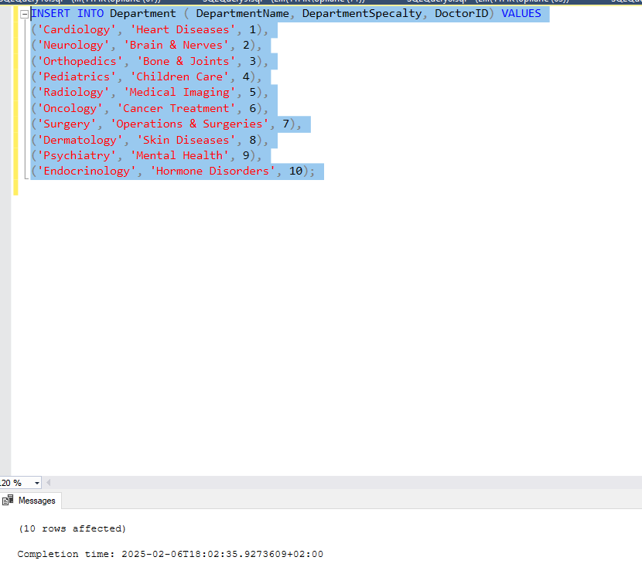

ALTER TABLE Patients ALTER COLUMN PhoneNr VARCHAR(15);

INSERT INTO Patients (Name, Gender, PhoneNr, CheckInDate, DepartureDate, DoctorID, WardID) VALUES

('Alice', 'Female', '444-4443', '2024-02-01', '2024-02-10', 1, 2),

('Bob', 'Male', '222-2222', '2024-02-05', '2024-02-15', 2, 3),

('Charlie', 'Male', '333-3333', '2024-01-20', '2024-02-05', 3, 1),

('Diana', 'Female', '444-4444', '2024-02-08', '2024-02-18', 4, 4),

('Edward', 'Male', '555-5555', '2024-01-28', '2024-02-12', 5, 5),

('Fiona', 'Female', '666-6666', '2024-02-02', '2024-02-09', 6, 6),

('George', 'Male', '777-7777', '2024-02-06', '2024-02-16', 7, 7),

('Helen', 'Female', '888-8888', '2024-02-10', '2024-02-20', 8, 8),

('Isaac', 'Male', '999-9999', '2024-01-25', '2024-02-08', 9, 9),

('Julia', 'Female', '000-0000', '2024-02-04', '2024-02-14', 10, 10);

